**Novia - No Violence App Report**

**Team ID: B21-CAP0213**

**Selected theme:** Women Empowerment and Child Protection **Mentor: Devina Ekawati** (mentoring done on Thursday, May 20th 2021 18.15-19.15 WIB)

**Member :**

1. **A0050493 - Farhan Deristianto Putra**
2. **A0080921 - Salomo Hutapea**
3. **M1481712 - Tassamu Akhsan Nugroho**
4. **M0050535 - Amyra Sarah Luthvia**
5. **C0050529 - Marissa Leviani**
6. **C2001975 - Achmad Rifki Raihansyah Bagja**

#### **Backgrounder:**

Based on a presentation from the Indonesian Ministry of Women Empowerment and Child Protection, the process of reporting from the victims of violence still took a long time to filter, prioritize and take action. Our team is initiating an application that can simplify these processes, which we call ‘Novia’ or stands for “No-violence app report”.

To understand the problem, we collect information about who was involved in the complaint service, what is the first step or action taken when the report comes in, and how long it will take to complete.

The current report system is still using the call center while there are too many reports to process. So, to process the report faster and easier we plan to create a chat-bot report with machine learning to simplify the process and make the report service more interactive.

* Machine Learning: Building Models with LSTM architecture and deployed the model through tensorflow.js, creating data dummy using data from paper and SIMFONI-PPA Website, Using sentiment analysis to detect the importance of report.
* Android: Building Novia Android app, starting from UI design using Figma, app development using Kotlin, implementing Clean Architecture and Android Architecture Components. The app consumes Novia API using Retrofit for sending chatbot reports and adding users to the database.
* Cloud: Building API using Node.js to get report and news data and use Compute Engine service to run the backend application. For the machine learning model, we store it into the Cloud Storage bucket. We also created a website to display the user report database from Cloud Firestore.

#### **Screenshots**

* **Android Application**

1. Welcome Page, Login and Register

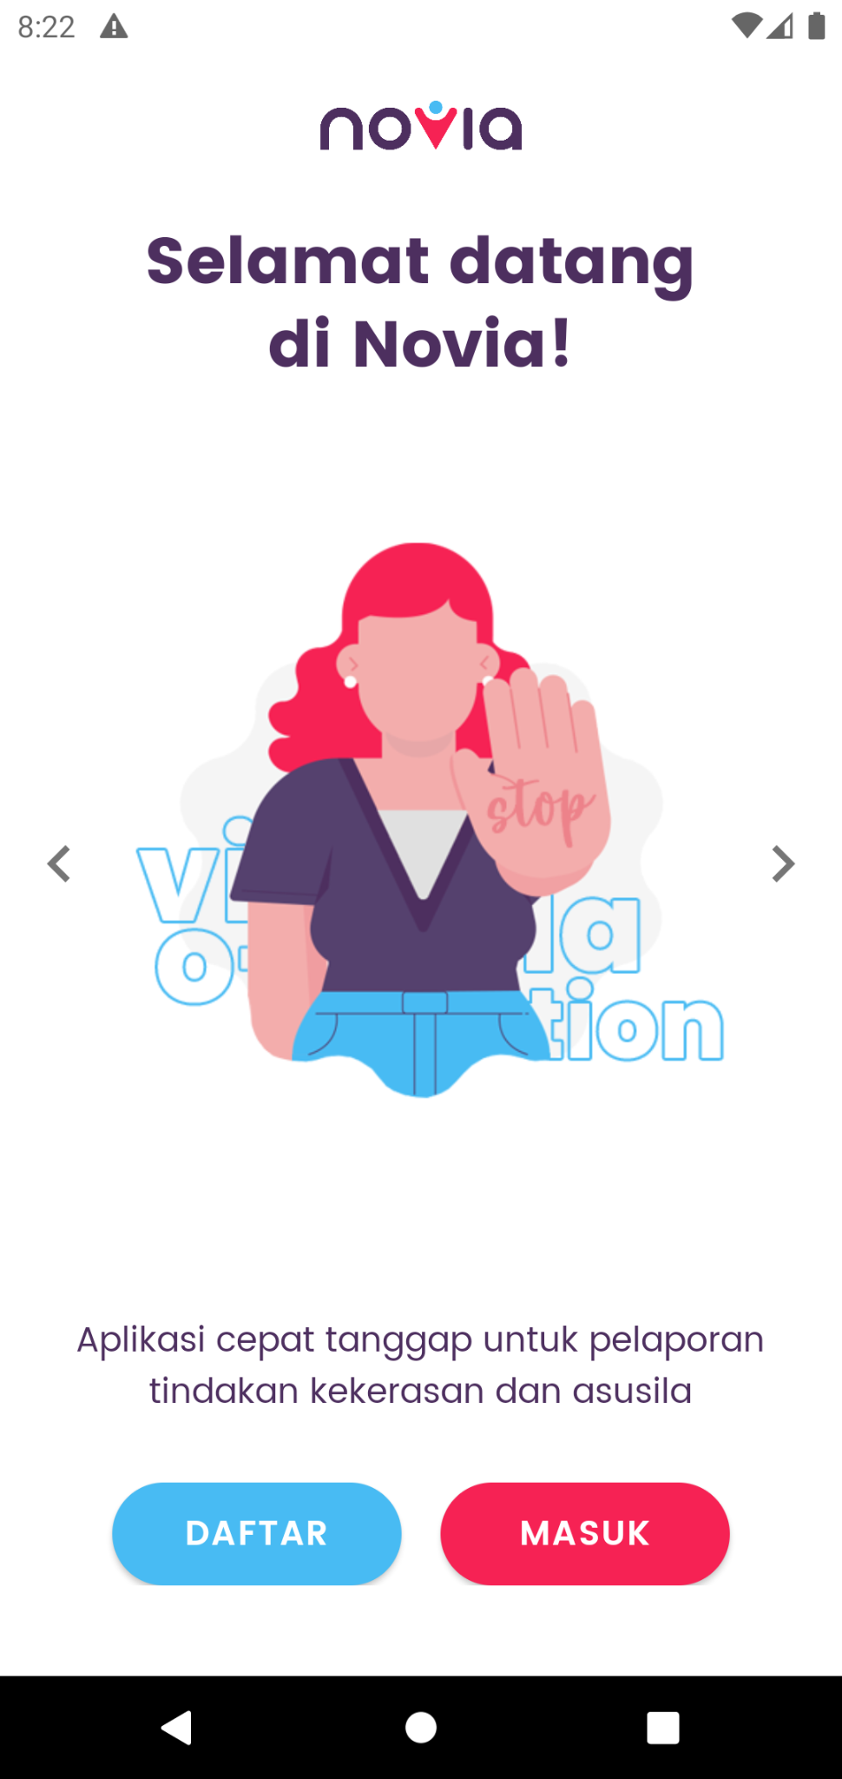 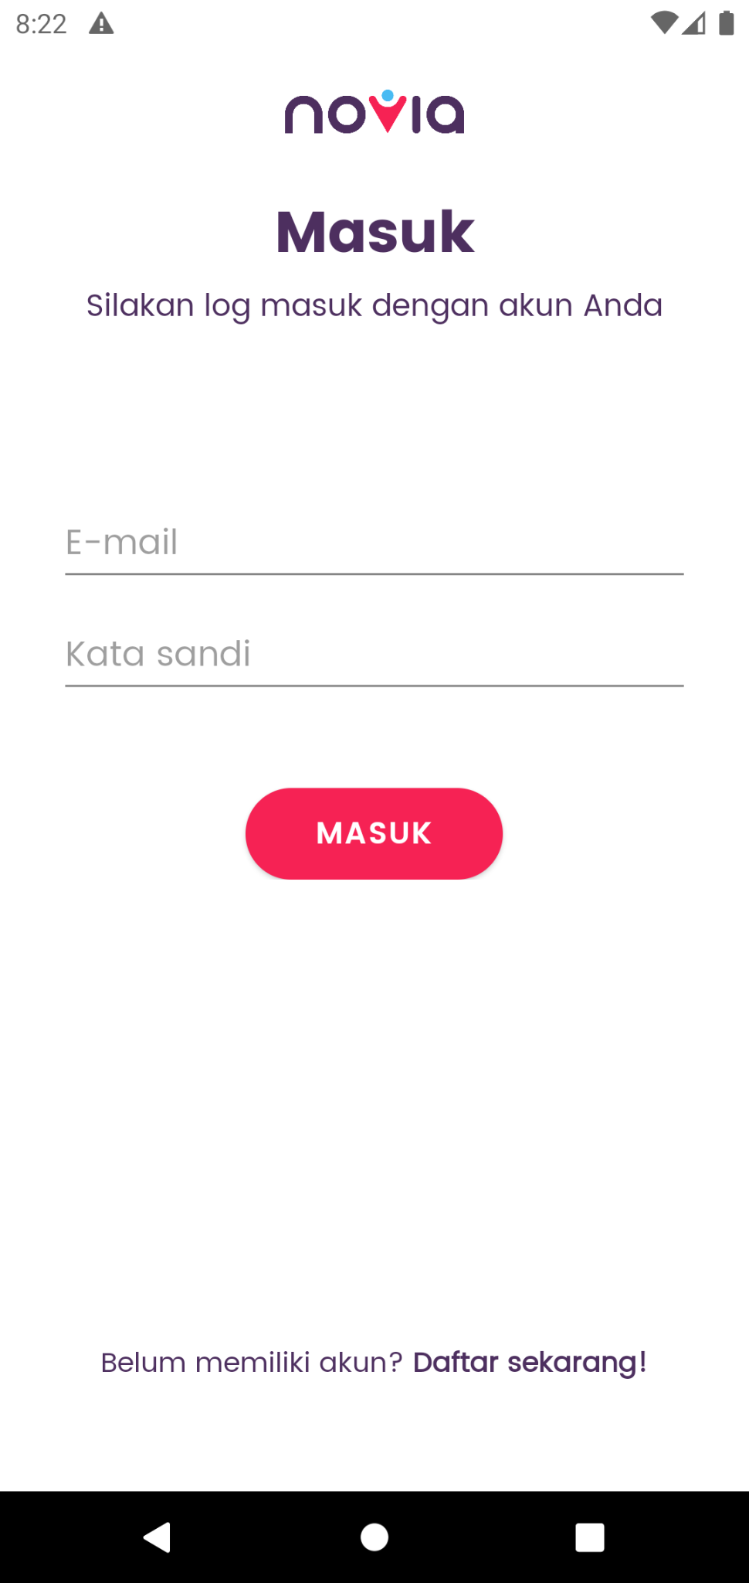 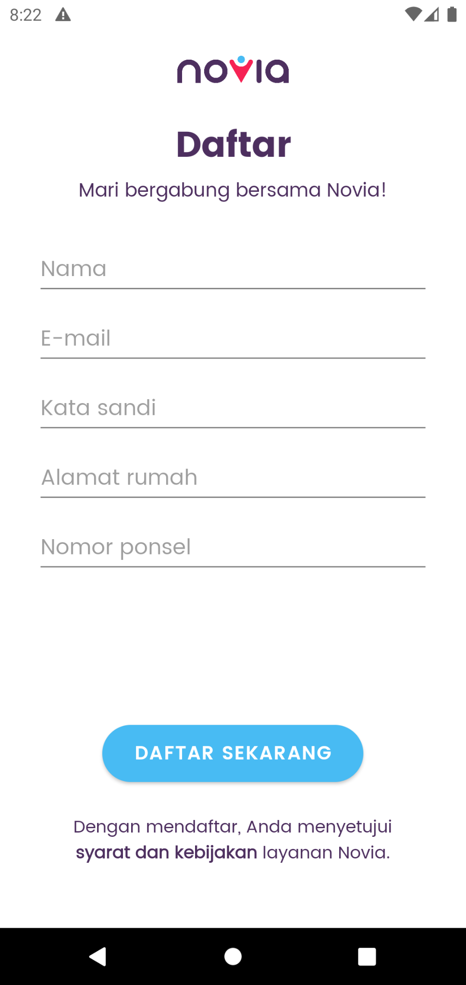

1. Home Page

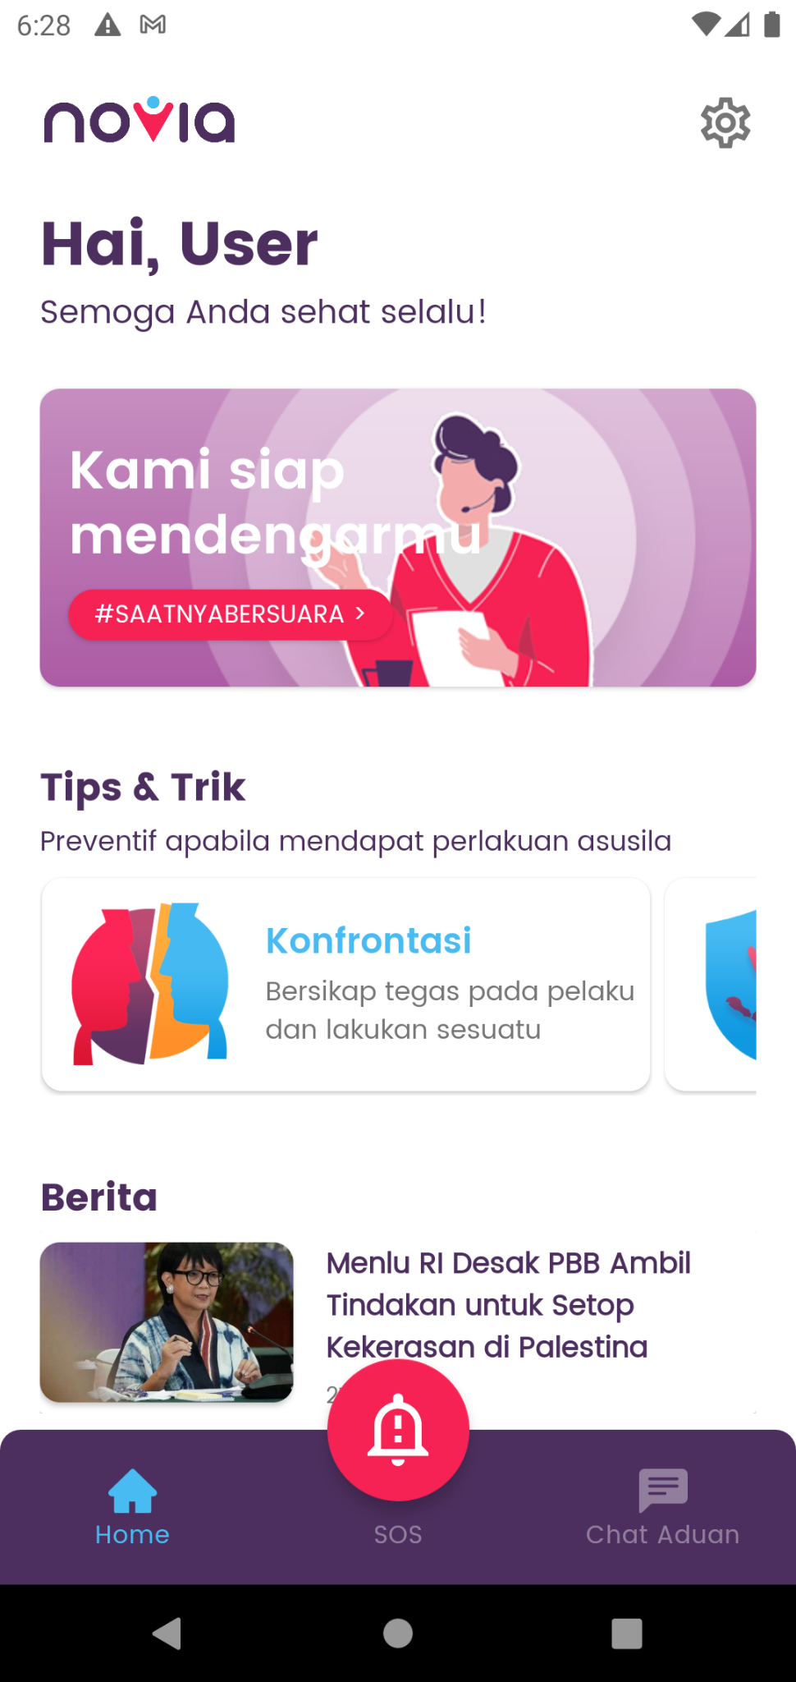 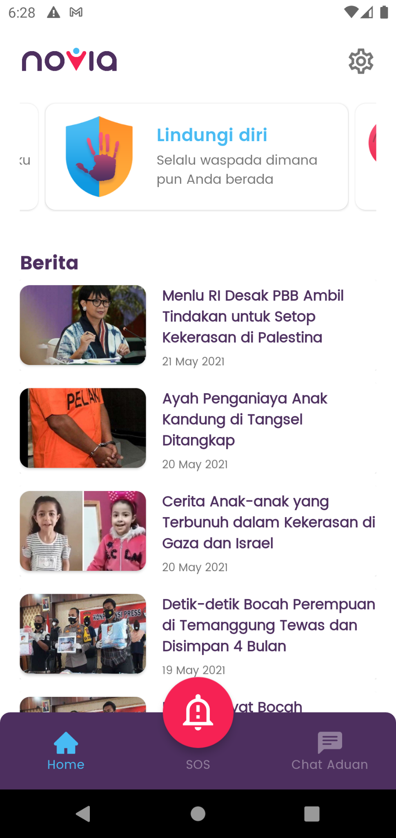

1. SOS and Add Contact Features

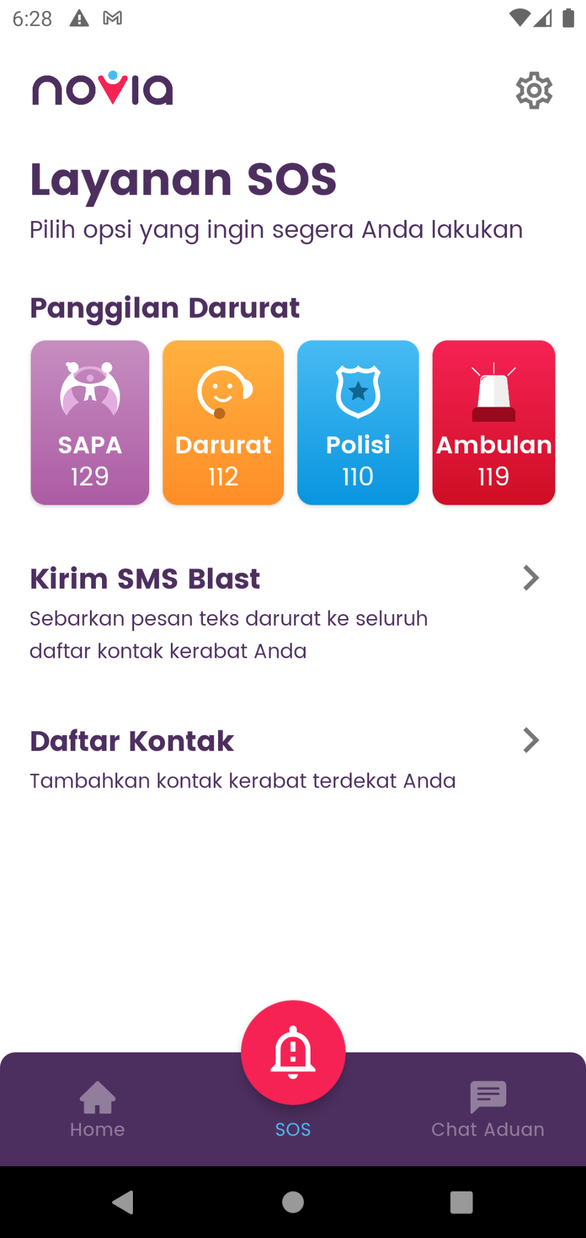 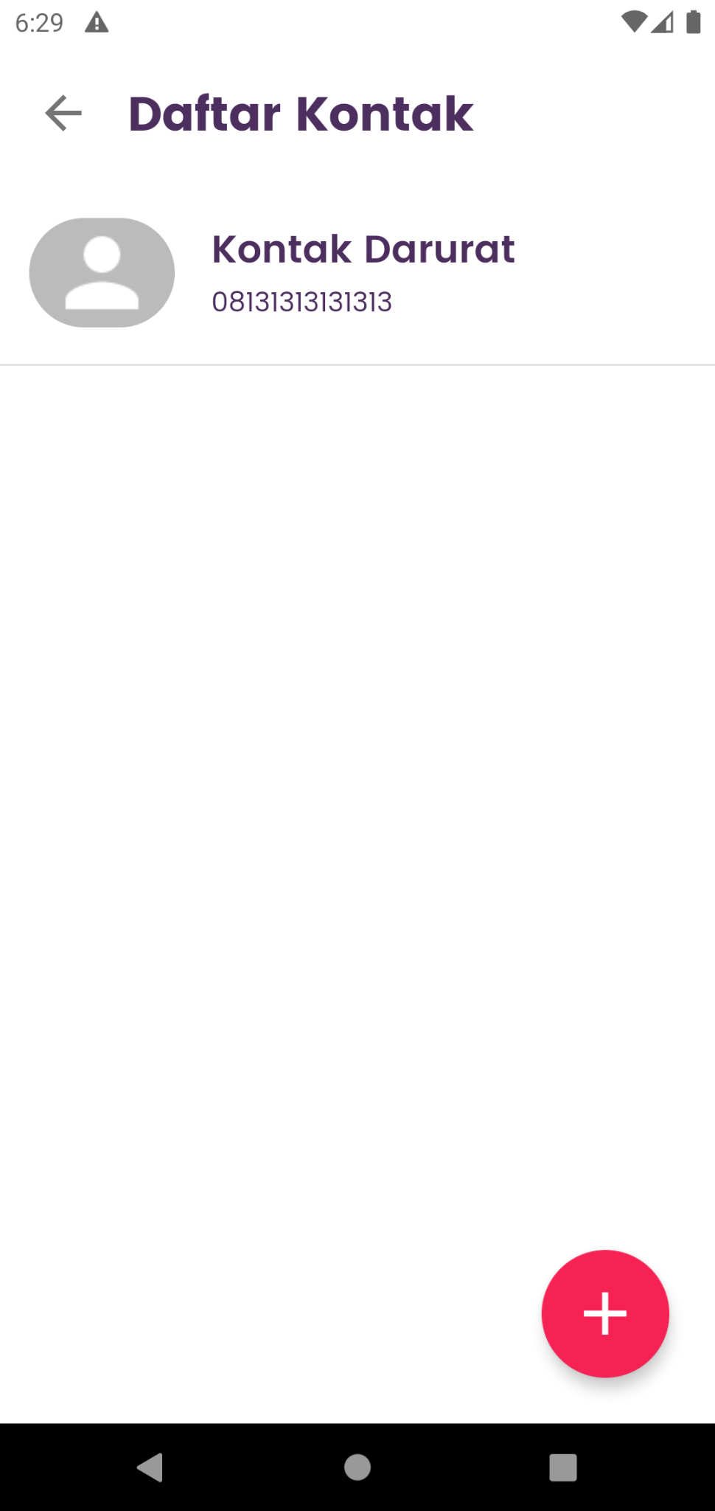 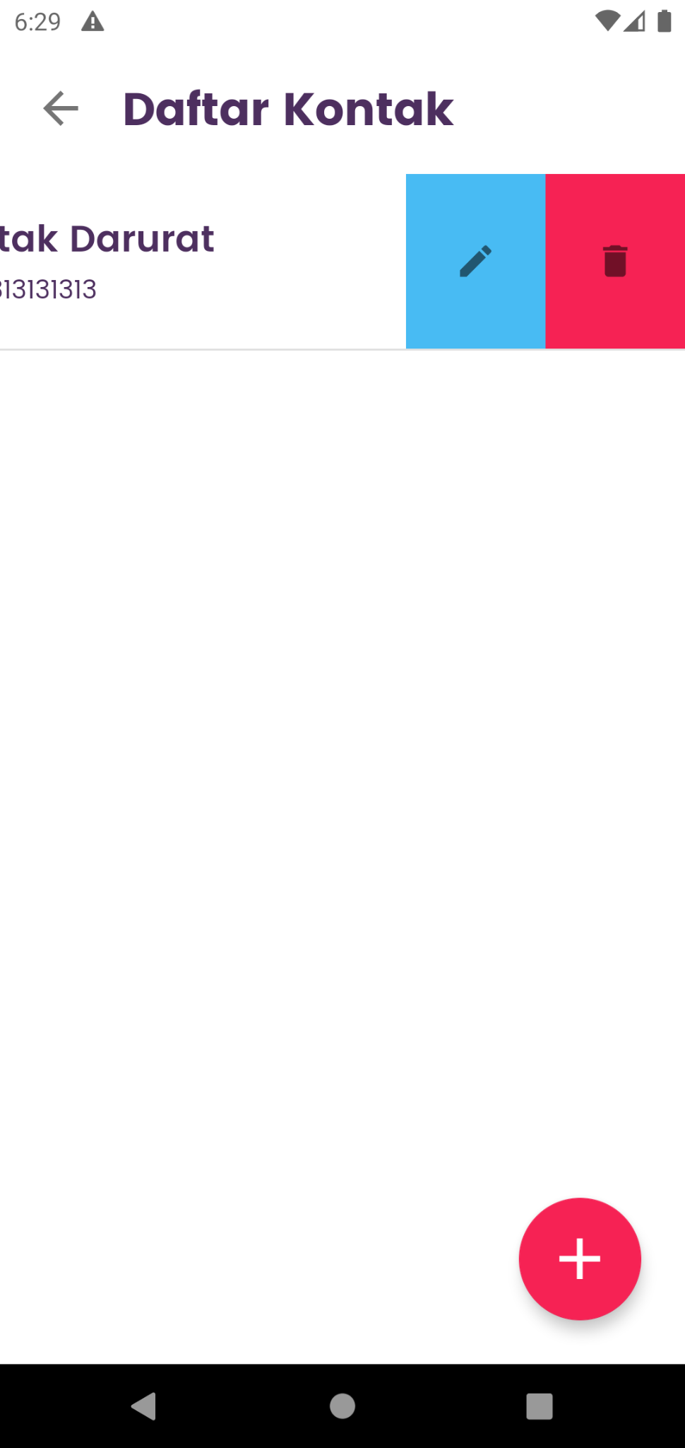

1. SMS Blast Feature (the automated message)

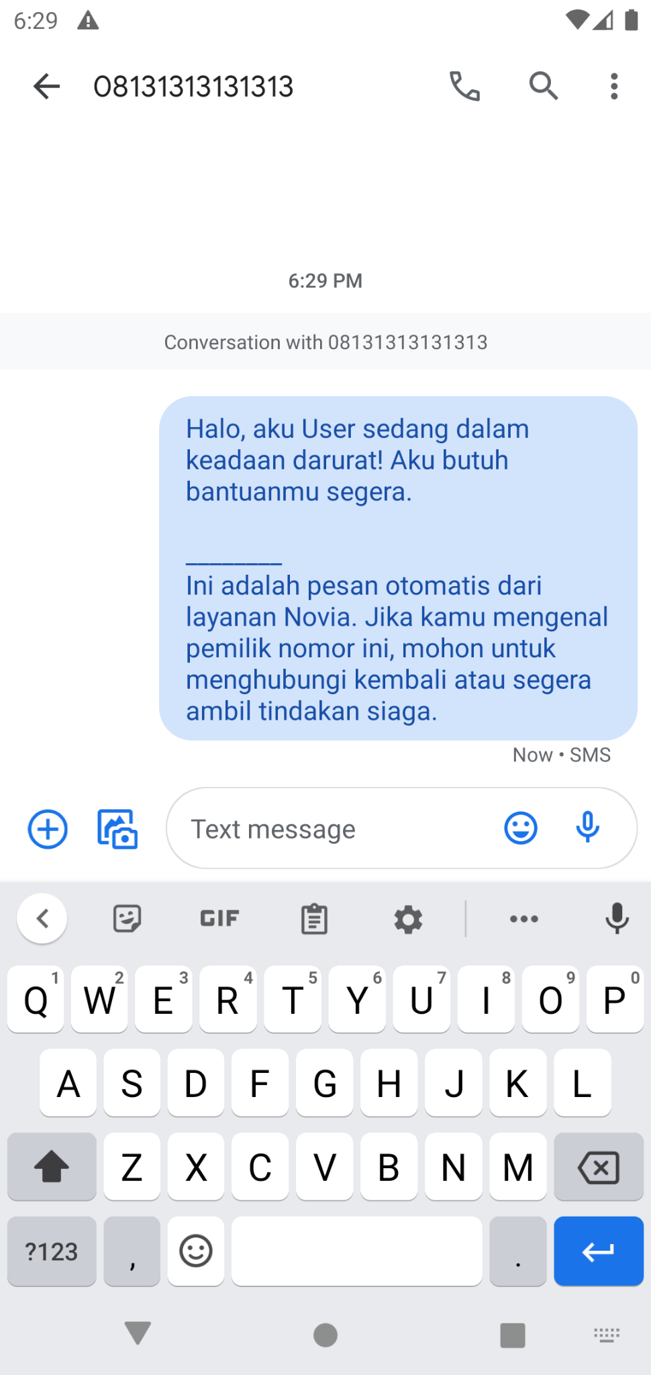

1. Settings Page

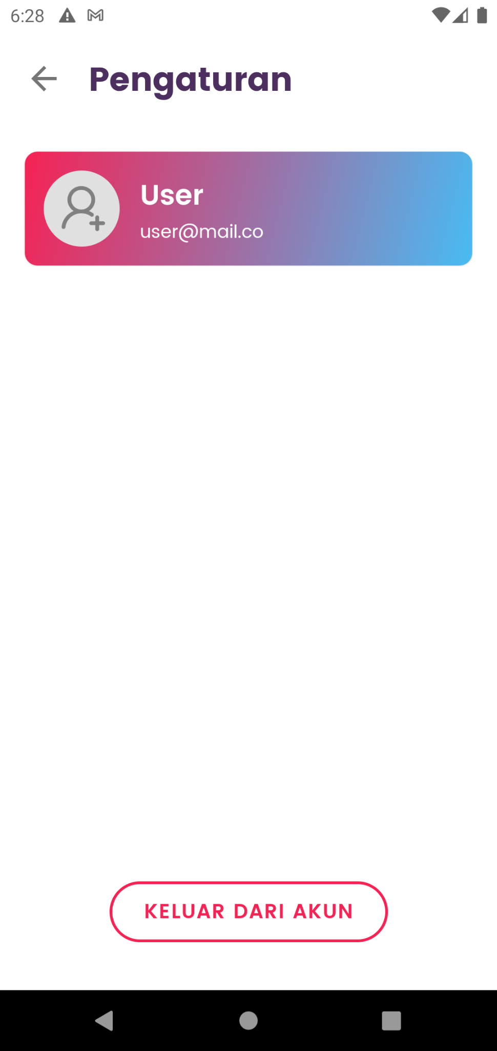

1. Chatbot Feature

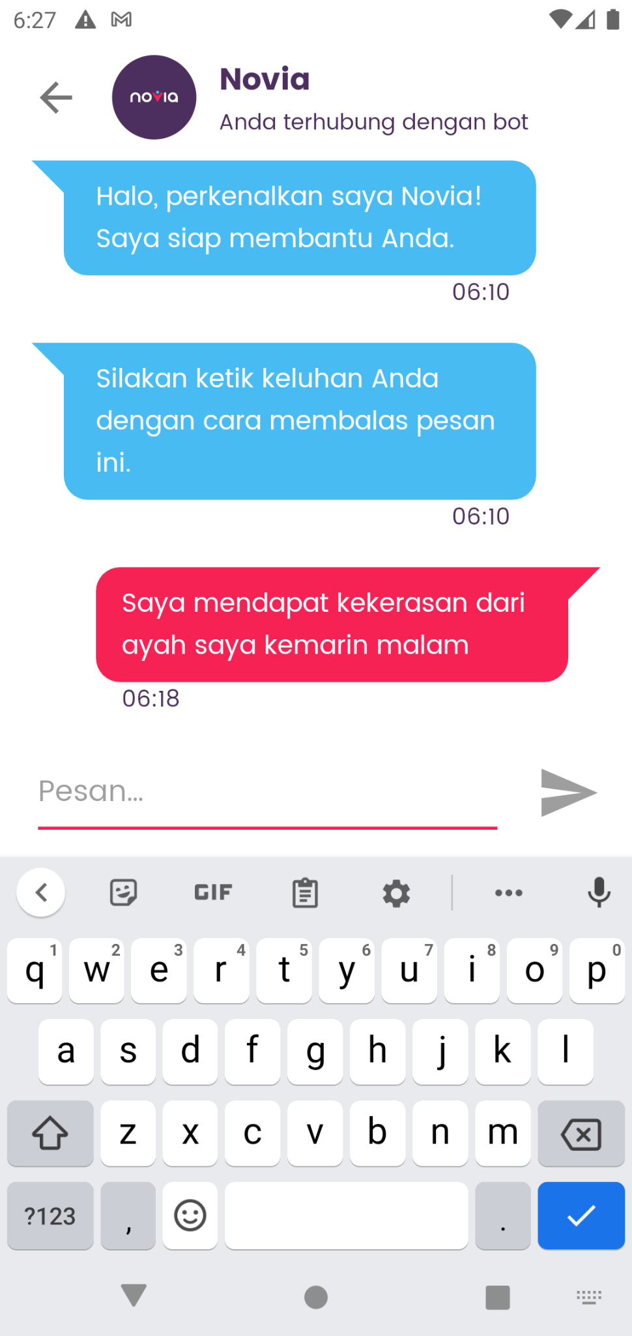

* **Administrator Website**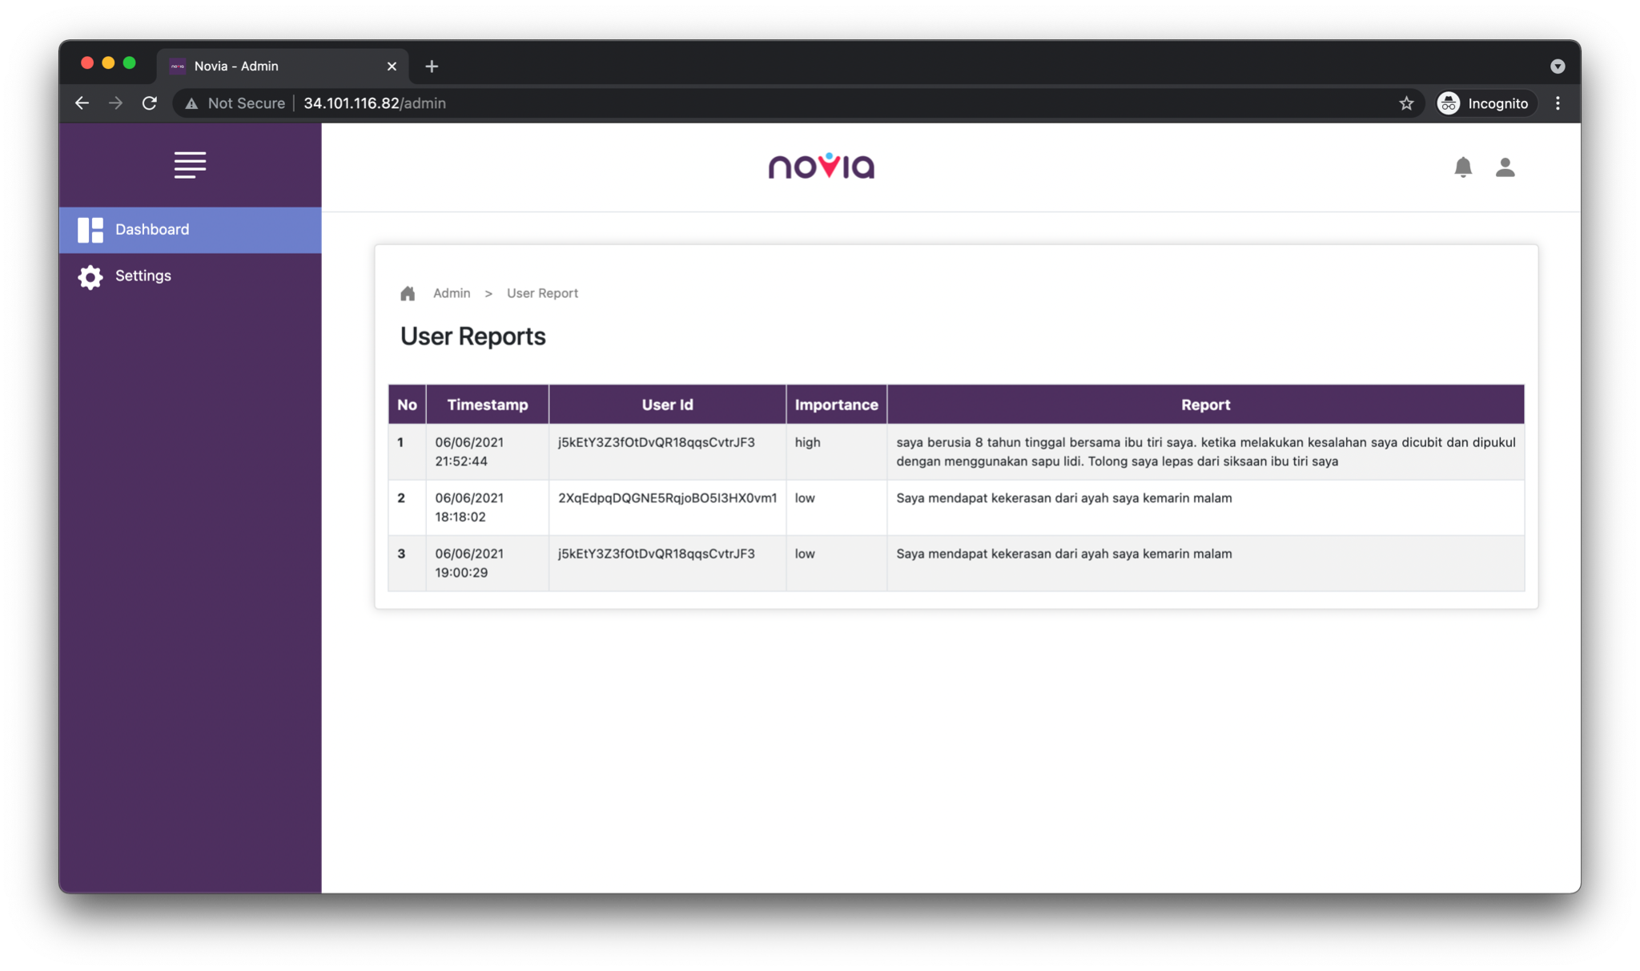
* **Machine Learning Model**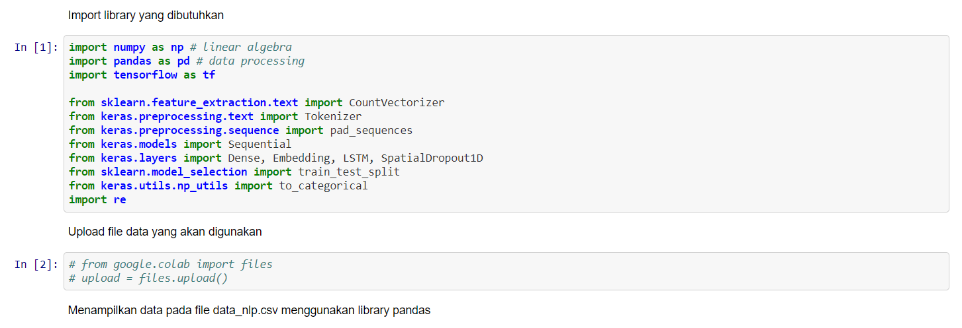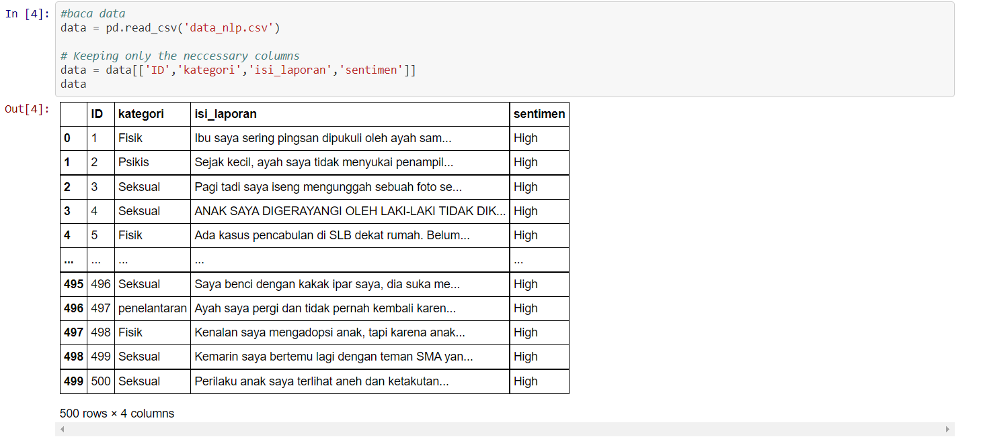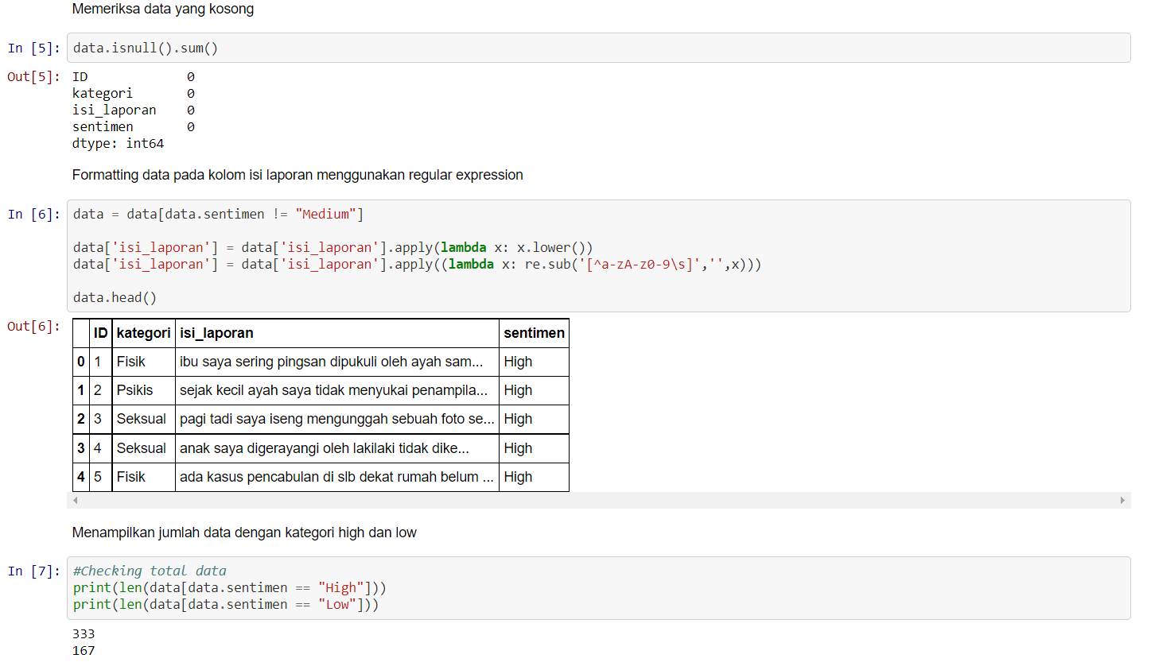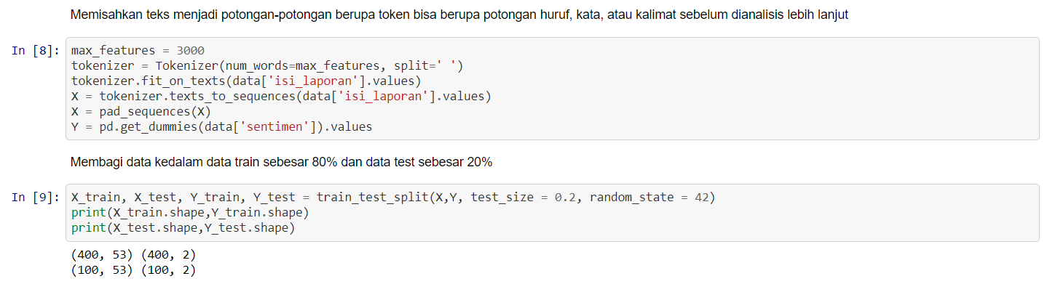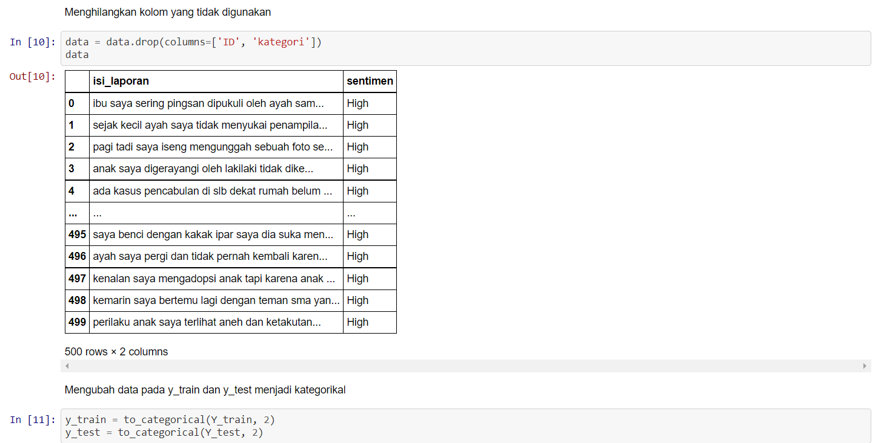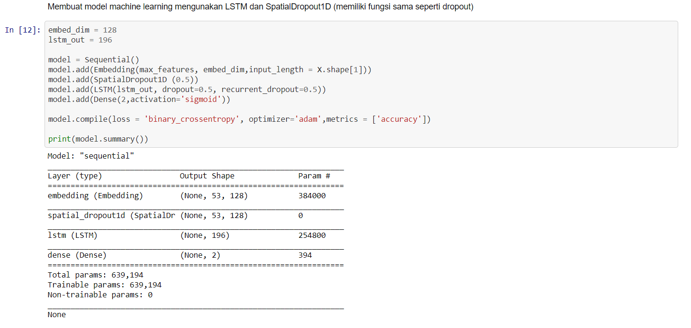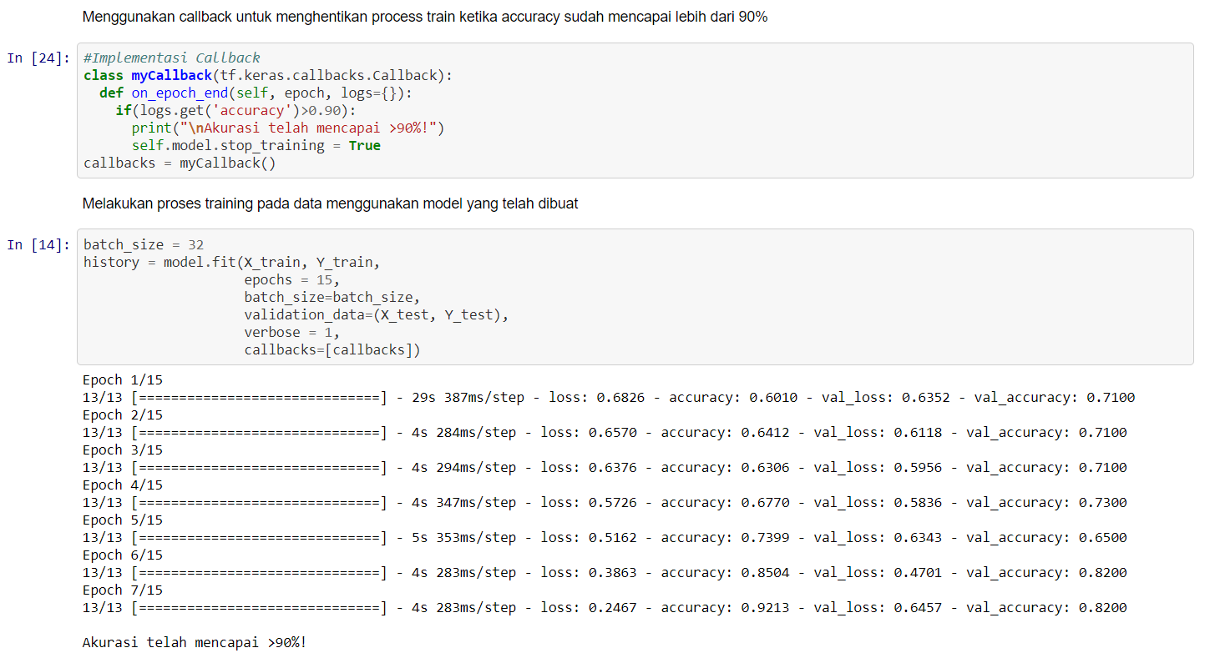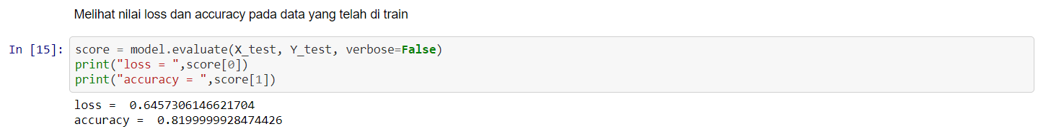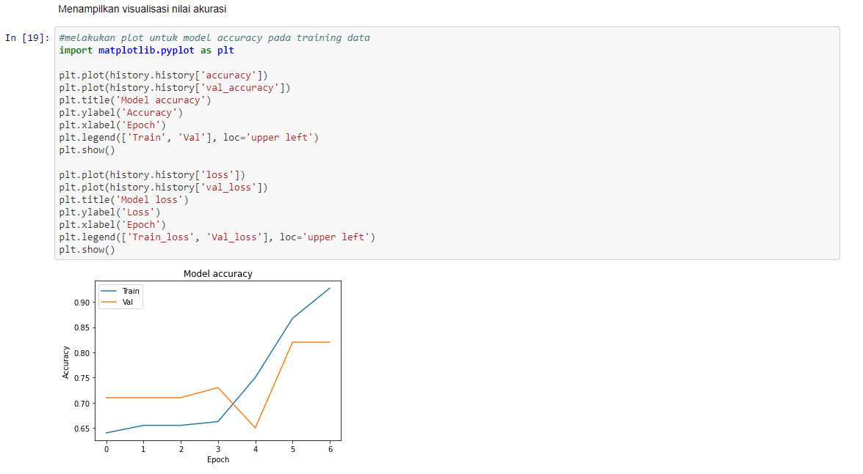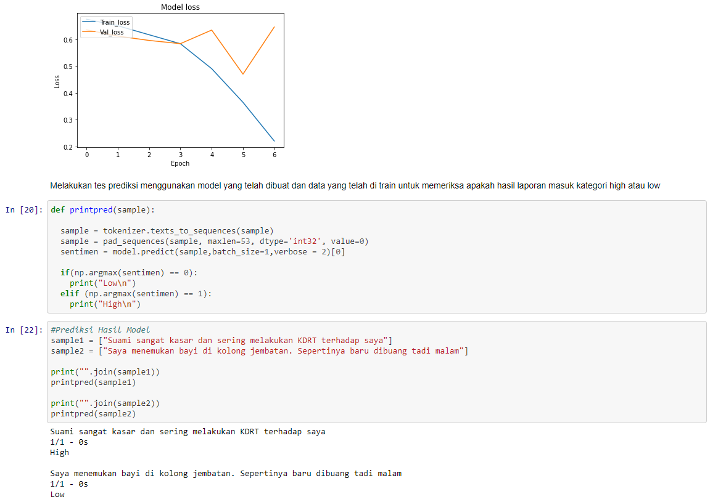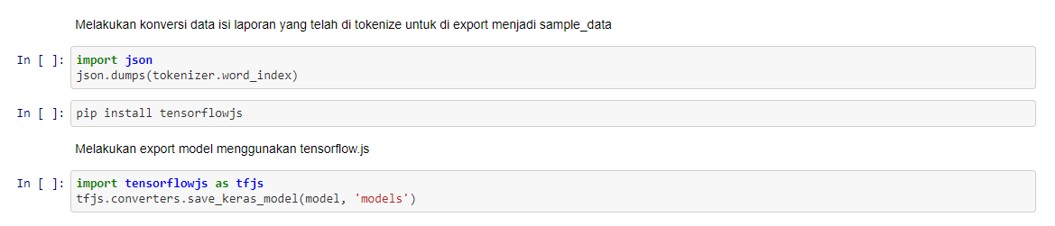

#### 

#### **Dataset Link**:

<https://www.kaggle.com/tassamoo/violence-report-on-women-and-children>

#### **Deployed Link:**

* Jupyter Notebook

<https://colab.research.google.com/drive/1Fl-DSTYenmg9nk-65WooivLEiur9beVT?usp=sharing>

* Android APK file

<https://github.com/Novia-No-Violence-App-Report/novia-app/releases>

* Administrator website

<http://34.101.116.82/admin>

#### **Github Repo Link:**

<https://github.com/Novia-No-Violence-App-Report>

#### **Academic Paper Link:**

Dataset:

* <https://media.neliti.com/media/publications/52819-ID-kekerasan-seksual-terhadap-anak-dampak-d.pdf>
* <https://media.neliti.com/media/publications/108131-ID-analisi-isi-kekerasan-seksual-dalam-pemb.pdf>
* <https://komnasperempuan.go.id/uploadedFiles/webOld/file/pdf_file/2020/Siaran%20Pers%20Komnas%20Perempuan%20Catatan%20Tahunan%20(%20CATAHU)%202020.pdf>
* <https://www.kpai.go.id/files/2021/02/MEDIA-RELEASE-LAPORAN-AKHIR-TAHUN-2020-1.pdf>
* <https://arxiv.org/abs/2105.11119>
* <https://journals.plos.org/plosone/article?id=10.1371/journal.pone.0247404>

#### **10-Min Video Presentation Link:**

<https://youtu.be/sZ_4-iaMPGQ>

#### **Slide Presentation Link:**

Product Slide:

<https://docs.google.com/presentation/d/1bTmyH-UajvTEXEVVk8itWgLboDm1F_yCI0ROgGTe7rA/edit?usp=sharing>

Go-To-Market Slide:

<https://docs.google.com/presentation/d/1DYDGDxwMu0tTMUdvMs6Qlyg3TjvIbxuwknksYrRNQw4/edit?usp=sharing>